Documentation TT-CAN

A time triggered communication protocol has deterministic behavior. This allows better fault tolerance and easier diagnosis. Therefore a time triggered CAN protocol is used for the systems communication.

**Matrix cycle**

For the time triggered CAN communication a matrix cycle is defined with 10 slots. Two slots are left sparse for future implementations.

Within the slots 5 different types of messages can be send.

1. *Trailer status* ***(TRLS1)****. Containing information about the read potentiometer value and local clock count. Each trailer has a fixed slot assigned for sending its status.*
2. *Truck status* ***(TRCK1)****. Containing information about the read potentiometer values, local clock count, set angle and requested motor angle. Each of the three truck nodes sends this message in an assigned slot.*
3. *System status* ***(SSTM1)****. Contains the current operating status and current fault codes detected by the system. This message is sent by the master board (one of the truck boards).*
4. *Synchronization message* ***(SYNC1)****. Message is used by all nodes in the system for syncing their local clock to the masters board clock. Contains the masters local count and the desired system state. This message is sent by the master board (one of the truck boards).*
5. *Membership message* ***(MMBS1)****. The membership message contains information about the amount of connected trailers and which truck board has the master role. This message is sent by the master board (one of the truck boards).*



Figure 1 Data sent per message

In figure an overview of the data sent per message can be seen. Since some data is longer than one byte it is sent over multiple bytes where the most significant byte (MSB) is sent first and the least significant byte (LSB) on the following byte.

Node ID’s count from 1 to 5, where 1 is always the truck board that also fulfills the master role and 4 and 5 are the node ID’s of the optionally attached trailers. These ID’s are used to construct the CAN ID’s, the first number of the CAN ID is the node ID of the node sending the message. The second number in the CAN ID is the slot number in which the message is sent.



Figure 2 CAN matrix cycle with assigned ID's.

**Implementation**

Which message must be sent depends on current slot number and assigned role. Incrementing the slot number occurs when the set slot time is elapsed. An interrupt is triggered once the slot time elapsed.

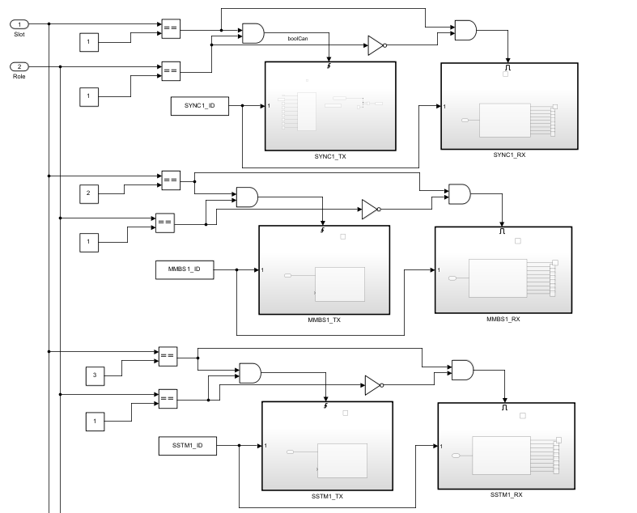

Figure 3 Example of selecting correct action

An example can be seen in figure 3. If the current slot equals 1 and the node ID is also 1 (master) the node sends the synchronization message. If the current slot is 1 but the ID of the node is not 1 it waits for receiving the synchronization message. This corresponds with the matrix cycle defined in figure 2.

There is no specific code needed per node. Once a node knows its assigned role it can determine when to send and when to receive a specific message.